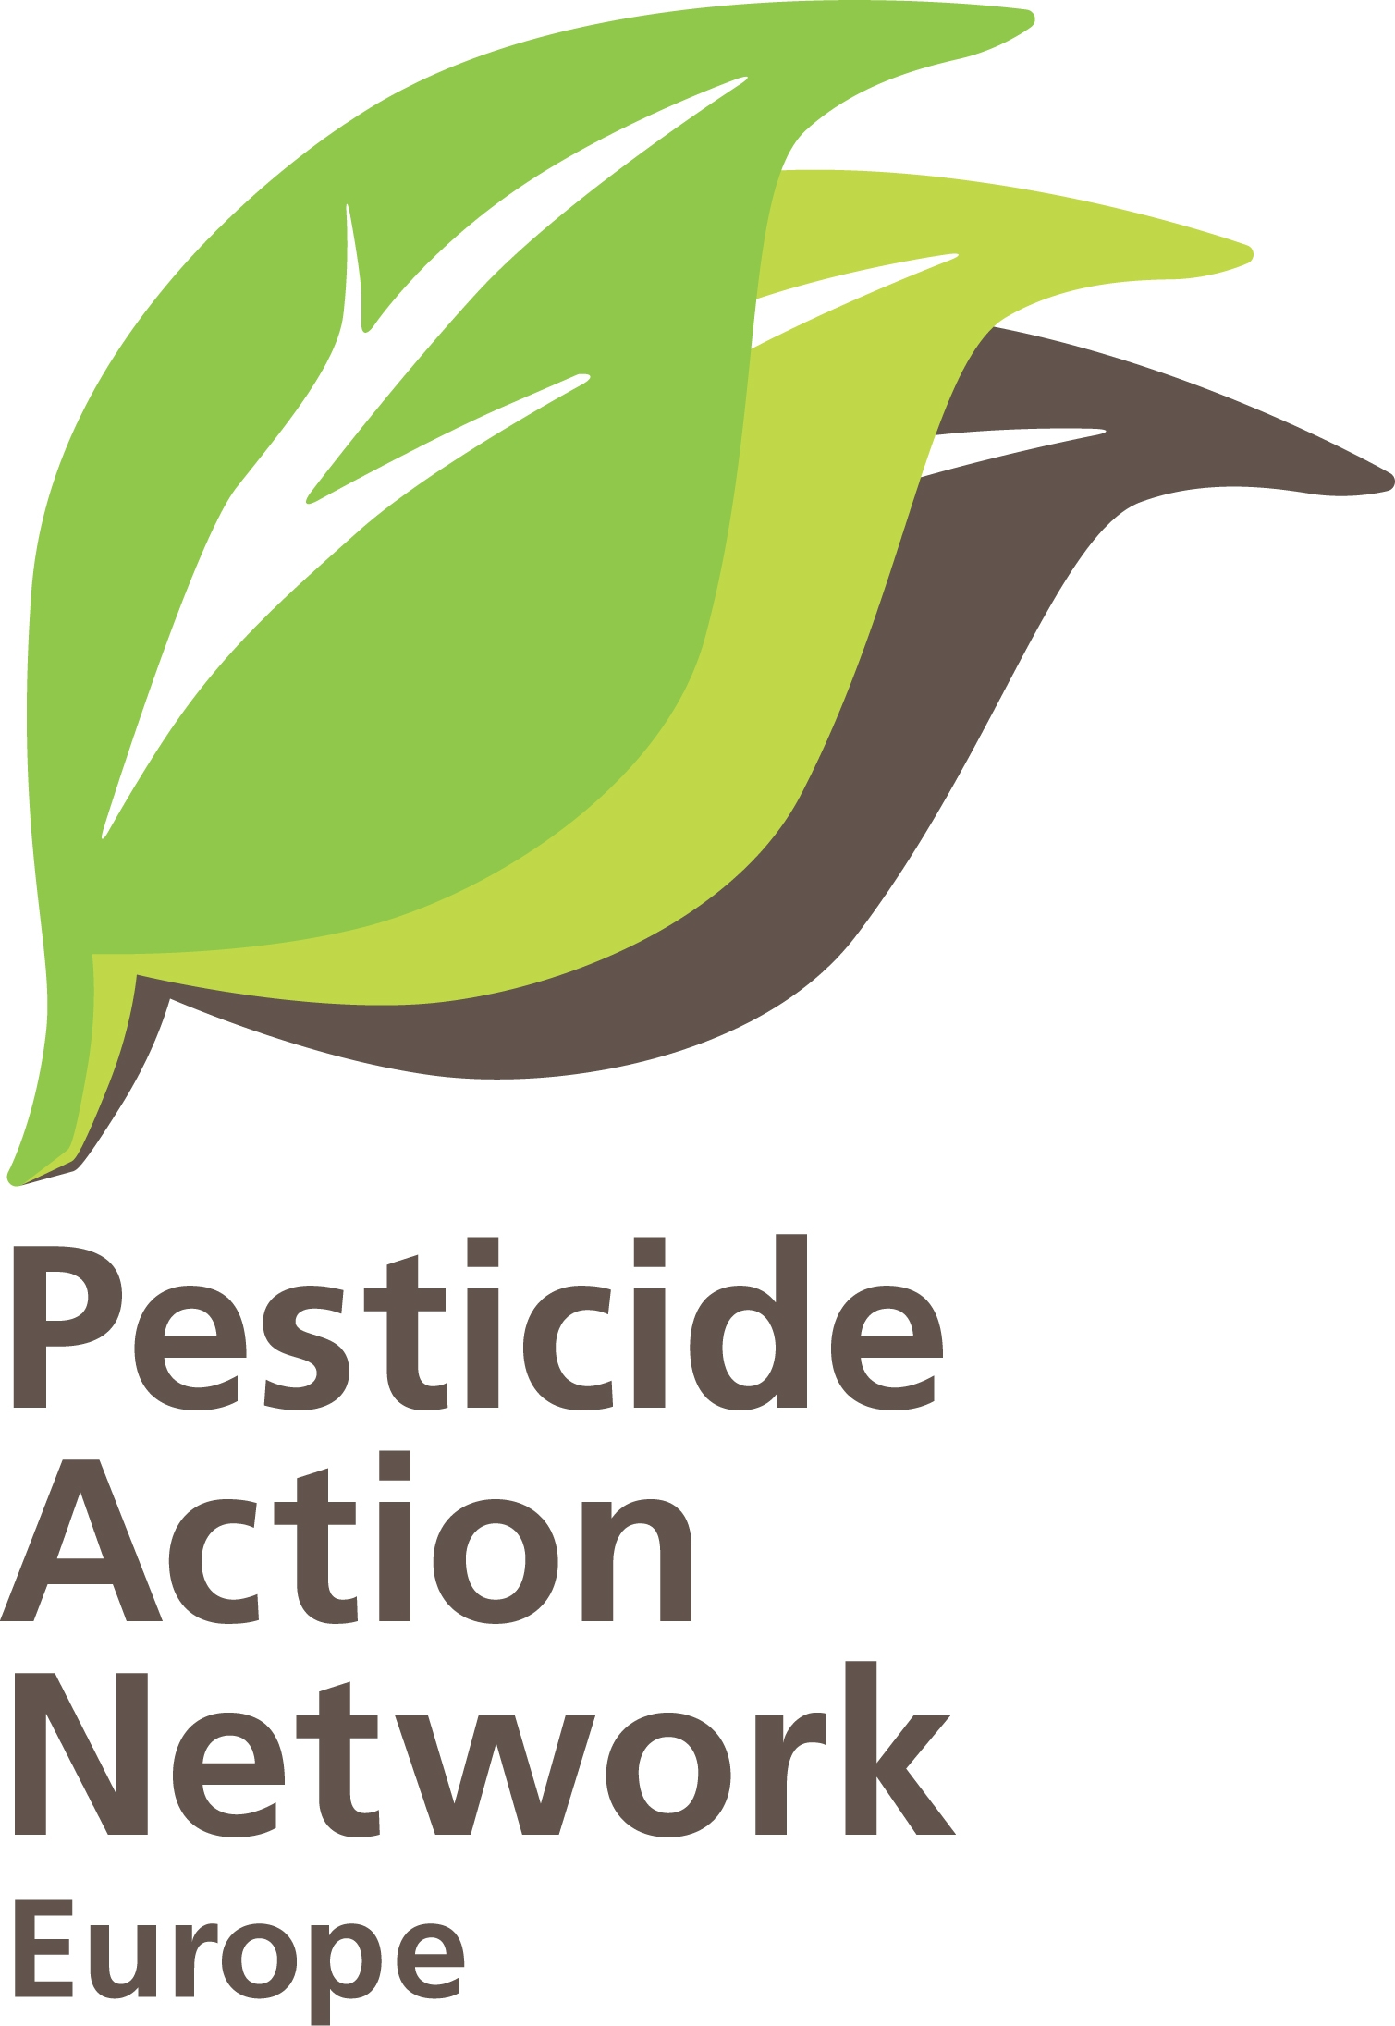 | PAN Europe comments to the data requirements for pesticides.  Brussels, 25 June 2011.  Contact: Hans Muilerman, hans@pan-europe.info,  tel. 00316-55807255.

Data requirements for pesticides and pesticide formulations

Our comments on the draft data requirements are as follows:

- Relying only on industry-sponsored studies creates bias
It is hard to ensure a fully unbiased outcome of the tests if industry-sponsored studies remain the basis of evaluation of pesticides. DG SANCO may state that it expects industry to deliver “unbiased” data – but how will this be realised in practice? There is simply no system in place to control bias and thus DG SANCO’s statement is no more than wishful thinking. Nobody outside industry laboratories knows anything about the quality of the studies, the bias, and even possibly the fraudulence of these studies. And it is clear that a company expecting hundreds of millions in revenues for a chemical they have worked on for so many years will never accept an unfavourable outcome in toxicological studies. This of course is known from the beginning by people working in the laboratory once they are commissioned to do a specific study. The likelihood of bias is supported by many articles published in scientific journals showing industry-sponsored studies have a more favourable outcome for a given chemical than studies from independent academic scientists. DG SANCO is closing its eyes to bias.

A first and foremost necessary step to return to a science-based evaluation system is to do all studies in independent laboratories (industry must pay for this through a levy). Industry could for instance pay a fixed levy for every individual study they have to do for their substance. An intermediate (JRC, ECHA?) should commission laboratories/academic bodies which are fully independent and have never had prior contracts with industry to do the studies. This would be the best way to reduce or eliminate bias. We ask you put such a system in place from 2014 on and not allow any industry-sponsored studies to be taken into account for evaluation purposes from that time on.

The second step in improving the situation is to take full account of the studies published in journals by independent scientists. Independent peer-reviewed studies should be seen as of highest reliability and quality because of the peer review they have undergone and because everyone can scrutinise the studies and identify any possible mistakes. Industry-sponsored studies have generally neither undergone peer review by independent reviewers nor are publicly available for scrutiny. The quality and reliability of industry studies are unknown. Industry-sponsored studies –as long as they are still used in evaluation – should be seen, at best, as useful with restrictions.
Unfortunately (11802, point 1.6) the text on independent studies mentions that only “relevant” data studies should be collected, creating a massive loophole for applicants to classify any unwanted independent study as “irrelevant”. The EFSA guideline published at the beginning 2011 on the use of independent science started this misery by allowing independent studies to be qualified as irrelevant or unreliable based on the notorious Klimisch study, authored by three employees of BASF who claimed that industry-sponsored studies are of the highest reliability and quality.
Therefore we urge you to delete the word “relevant”.

- Industry is allowed flexibility.
As long as we have the unwanted system of industry-sponsored studies, flexibility in the studies should be kept to the absolute minimum. Evaluating bodies simply have no idea what happens in the ‘black box’ of industry laboratories. The obligation to report according to GLP doesn’t change this. Anything can be reported and there is no way of finding out what really happened. The verification system of GLP is weak and about audits we didn’t hear for a very long time
The idea to allow applicants to choose 1 of the three in vivo genotox tests is asking for trouble. Who knows if the applicant performs all three studies and submits only the most favourable one? Nobody will know. We propose to oblige applicants to do at least two in vivo genotox tests.
The derogation possibility for long-term/carcinogenicity tests (11802, point 5.5) is also quite remarkable. This crucial test should always be performed, without the possibility of waiving it. The waiving of the mouse study is unwanted. Additionally long-term studies should cover the entire lifetime of a test animal.
The waiving of the neurotoxicity study (11802, point 5.7) is completely illogical. It is much too conservative to restrict this to chemicals acting as a neurotoxic substance in plant protection. From a biological point of view this cannot be understood; every organ in a body uses the nervous system. So clearly this study should be an obligation for every pesticide.
The flexibility of the choice of species (like 90-day rat, rat in long-term studies) should not be allowed as it permits cherry-picking, for example, for least sensitive species.

- Non-science based methodologies must be abandoned
Gradually, and stimulated by industry lobby clubs like ILSI and SETAC, methods of assessment are introduced in pesticide evaluation which lead to more favourable outcomes for the applicants. It is time to abandon these methods especially now that the new Regulation has entered into force and a hazard-based approach has been introduced.
Allowing (and even encouraging) questioning if a given effect seen in test animals is relevant for humans (like 11802, point 5), is one of these bad ideas. Applicants will have no problem identifying differences and even the narrowest unverified species difference in absorption, distribution, metabolism or excretion will give rise to a discussion on the disqualification of observed adverse effects in test animals. This again creates a loophole and undermines the testing system itself. Adverse effects disregarded in this way turn the precautionary principle upside-down, giving the benefit of the doubt to commercial parties. Only in very specific cases and only on the basis of absolute scientific proof, should irrelevance be admitted. Any doubt must always lead to the default assumption of relevance to humans.
Another bad habit is the use of “historical control data”. This again can give rise to manipulation and undesirable discussion. In good quality independent science, the use of historical control data is not seen as scientific and is not normally allowed. We propose to delete this element and oblige applicants to use enough control animals in their studies.

Using “safe levels” for impurities (1g/kg, 1000 ppm!) without any toxicity testing (11802, point 1.10.1) and the opportunity to classify metabolites as safe (11802. point 4) also does not contribute to a scientific approach and should be deleted.

- Science-based methods must be embraced
Science progresses, so we expect data requirements to change in time. Unfortunately, scientific progress is not reflected very much in the text. More and more evidence is presented in scientific journals on the adverse effects of low doses and vulnerable phases of organisms. If it is SANCO’s real intention to reduce the negative impact of pesticides on health, this should be one of the priorities. But even in the chapter on developmental toxicity (11802, point 5.6.2) nothing is stated about the need of testing low doses and the need of exposure during critical windows at development. Without these elements many tests are futile and allow applicants to generate a favourable outcome. We propose to include low-dose testing, and if possible, based on published science – to do exposure tests at the right timing.
Another element missing, we sadly have to say after discussing this for decades, is the combination effects of different pesticides and other chemicals in the environment. The completely unscientific approach of one-chemical-in-an-entirely-clean-world-testing is maintained. This is in spite of the fact that Parliament and Council included this element already in the 2005 residue Directive and in the recent pesticide Regulation. This means people and the environment will continued to be exposed to unknown risks. We propose to include a combination assessment in all cases.

- Where are the tests for immunotoxicity and endocrine disruption?
There is a mention of these adverse effects in the introduction but no mention of actual testing obligations. Immunotoxicity and endocrine disruption are very well known adverse effects, the effects can be very damaging at high costs for society, and people and the environment should be protected against such effects. Mentioning the effects (only under supplementary studies 911802. point 5.7) is not very helpful. Also the new OECD 1-gen reprotox study (a substitute for 2-gen repro – a substitition that we strongly oppose) in the final version disregarded the immunotox (and neurotox) elements. We therefore urge you to include tests for these effects.

- Formulations (11803).
The data requested from formulations are very few. Any chronic test requirement is missing, even though this formulation is exactly the mixture people are exposed to in daily spraying in the fields. In many situations (like the substance glyphosate and the formulation Roundup) there is a remarkable difference between the two. Only testing the substance might underestimate the toxicity of the formulation to a high extent. We propose to – at least – add one chronic test for formulations.
Quite strange is the lack of attention paid to Integrated Pest Management (IPM) in the data requirements. From 2014 onwards, IPM will be the baseline in European agriculture. The fact that it is no mentioned here means that the substance under consideration may not respect this baseline or might even harm the introduction of the baseline. We think in the chapter, “Efficacy”, data should be generated by the applicants, showing that in all cases and all crops, the formulation can be a useful element of IPM (obliging MS to restrict the authorisation to just this element), and does not harm IPM in any way.

In summary we ask you to:
- End the use of industry-sponsored studies in evaluation of pesticides by 2014, and perform only studies in independent laboratories (paid for by industry);
- Delete the word “relevant” on independent science (11802, point 1.6);
- Limit the waiver possibilities in studies and the flexibility;
- Delete the waiver option for long-term/carcinogenicity test (11802, point 5.5);
- Delete the waiver possibility of the neurotoxicity test (11802, point 5.7), which should be done in all cases;
- Oblige applicants to do at least two in vivo genotoxicity tests;
- Disallow flexibility in species choice (90-day rat, mouse long-term);
- Do not allow (or even encourage) a discussion on the relevance of the outcome in animal tests for humans (11802, point 5);
- Do not allow use of historical control data for testing;
- Disallow the possibility of classifying a metabolite as irrelevant (11802, point 4) unless testing proves this;
- Delete the “safe level” of 1000 ppm of impurities in substances (11802, point 1.10.1);
- Introduce new insights in science like low-dose testing and exposure timing at windows of vulnerability, especially in the developmental testing (11802, point 5.6.2);
- Take combination effects (between different pesticides, but also other stress factors in environment) into account in all cases;
- Include tests for immunotoxicity and endocrine disruption;
- Add at least one chronic test for formulations (2-gen);
- Do not allow substances to disrespect the IPM-2014-baseline and authorise a substance only if it contributes to IPM.

